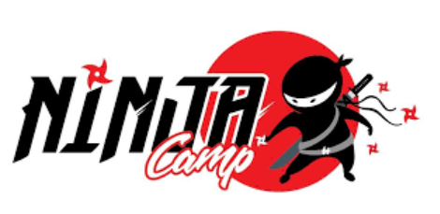
SALEM & LONDONDERRY CAMP
2022 SUMMER RATES Member & Non-Member Rates
The Workout Club & Ninja Fit Club kids camp summer of 2022 is for children 5-12 years of age. Register your children for full or half days. Activities include swim, splash park, rock climbing, Ninja classes & free time, outdoor games/sports, kids intro to all thing’s fitness, team building games, arts/crafts. Activities may vary by location. Morning swim only in Ninja camp.

PLEASE READ BELOW
REGISTRATION FOR SUMMER CAMP OPENS ON FEBRUARY 1ST, 2022.
DEPOSITS ARE CREDITED TOWARD ANOTHER WEEK OR CAMP IN 2022
A NON-REFUNDABLE DEPOSIT OF $50 PER CHILD PER WEEK IS REQUIRED UPON REGISTERING.
ALL BALANCES MUST BE MADE IN FULL ON OR BEFORE JUNE 10TH, 2022.
Additional 10% off for siblings.

NO EARLY DROP OFF AND NO LATE PICK-UP (Child-care may or may not be available in all locations)
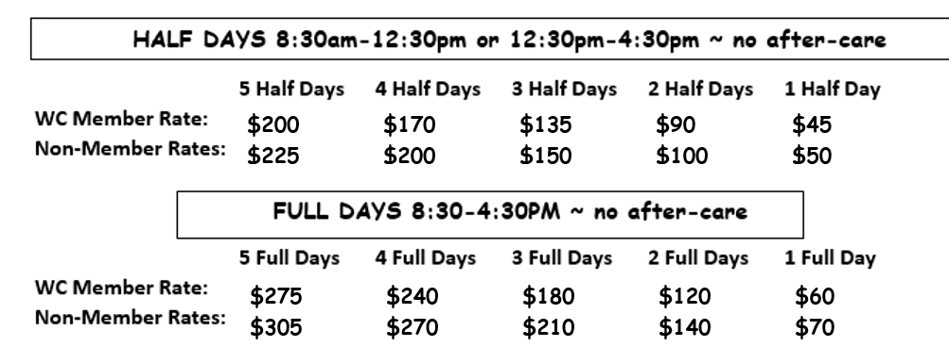

Deposits are non-refundable; however, they can be used for a different week if there is an availability or toward a future camp in the same location.

Please return registration with days or weeks needed and confirm your spots with a $50 per child/per week non-refundable deposit. Deposits or payments will be refunded if the Workout Club or Ninja Warrior Fitness cancels a day or week of camp.

Please send dates for both locations to annmarie.caprio@theworkoutclub.com
Reservations and payments can be made via credit/debit card and if needed can be made weekly up until the due date of June 10th, 2022.

*ALL BALANCES MUST BE PAID IN FULL BY JUNE 10th, 2022
Annmarie.caprio@theworkoutclub.com ~ 603-341-8002

